CS 340 README

About the Project

Grazioso Salvare is a company that identifies dogs that would be good candidates for search and rescue training. In this project, Grazioso Salvare has partnered with different animal shelters to search for dogs that meet a specific criterion. Using the existing data provided by the shelters on these animals, Grazioso Salvare should be able to identify potential candidates for the program quickly.

Motivation

Each dog breed performs better under certain conditions for search and rescue jobs. Grazioso Salvare wants to categorize dogs that may perform better under certain conditions to locate humans after a disaster. This project exists so that candidates can be obtained quickly.

About the Tools

The Pymongo library within MongoDB is a versatile tool that makes CRUD functionality more intuitive and the handling of data far easier. MongoDB also naturally maps well to the Python language because of Python’s built-in data types.

Jupyter Notebook is great for writing and debugging code thanks to its interactive format, and it also works well for projects that could be reproduced by others.

The Dash Framework makes for great and easy-to-use visualizations of data. The framework is dynamic and updates in real time to whatever data is provided.

Installation

Install mongosh here: https://www.mongodb.com/docs/mongodb-shell/
After the installation of mongosh, install MongoDB server here: https://www.mongodb.com/docs/manual/installation/ (be sure to select the appropriate one for your operating system)
Jupyter Notebook can be installed here: https://jupyter.org/install

Getting Started

To begin this project for yourself, follow these steps:
- Load MongoDB and import the aac_shelter_outcome.csv into the AAC database, using the animal’s collection.
- Create both a simple and compound index for the loaded files
- Create an admin and “accuser” (ACC-user) account with reading and writing capabilities.
- Ensure that you keep a record of the user authentication for later access
- Download the available Python files and upload them to Jupyter Notebook.
- Ensure that a connection status has been received.
- Run the software and ensure that all functionality is accessible.

Usage

This program can read the animal shelter database, create and update entries, and delete existing entries. This program can also be used to filter for animals that meet specific criteria and locate them geologically.

Animal insertion can only be done via the Python module or the database. To add an animal via the module, follow these steps:

- Write out your animal’s information and ensure that the full criteria has been met.

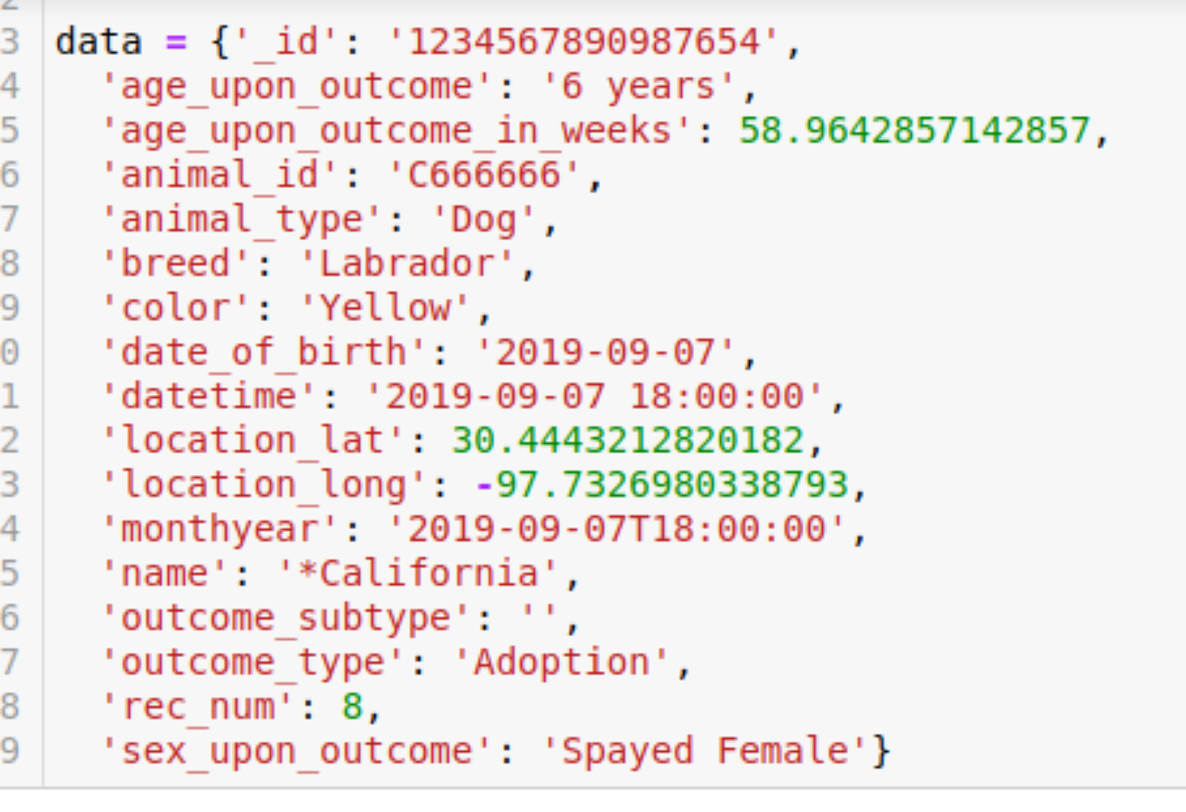

- Ensure that the animal was added via the built-in confirmation.



You can use the read function to find animals that meet a specific criteria, here is the animal we just added:

You can also update the animal's information by inserting a specific animal's ID and then changing any relevant information on the animal like so:

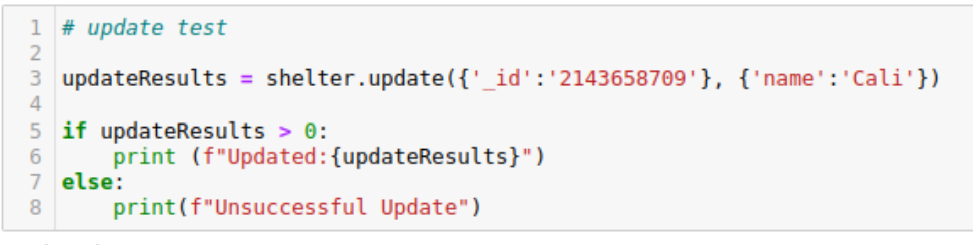

And ensure that an update occurred:
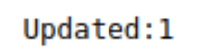

You can delete an animal using its unique ID. Just insert the animal's ID like so:

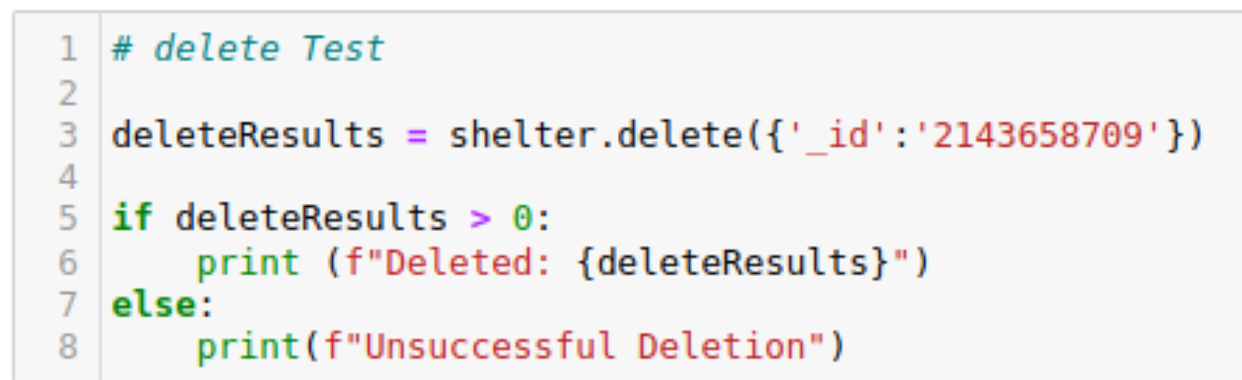

And ensure that it was truly deleted

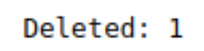

The data table has filtering, reading, updating, and deleting functionality as well. Simply run the module that starts the table and ensure you get this page.

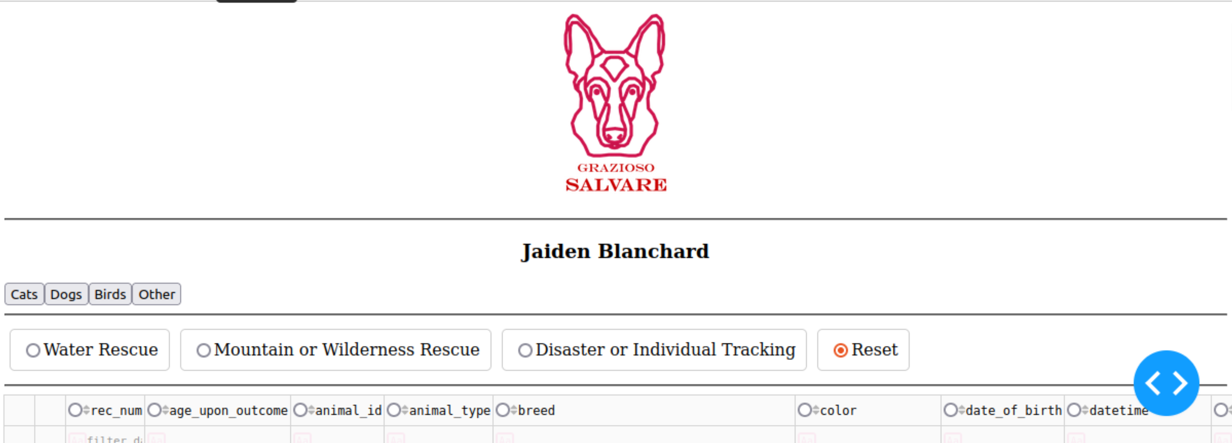

Scroll to the table and filter by any options you want, whether it be by animal or rescue type. Please note: the animal buttons are dependent on which buttons have been pressed the highest number of times, it may be helpful to refresh the page to reset the counter. The rescue buttons only filter for dogs so if you press one and the page comes up blank, ensure you’re not accidentally filtering by other animals first.

Results of the table after pressing “birds”
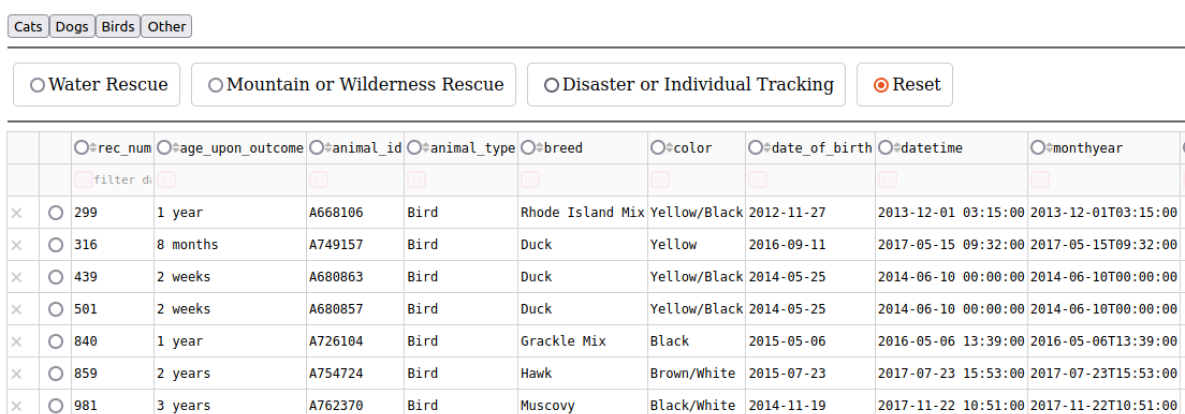

Results of the table after selecting “dogs” and “Water Rescue”
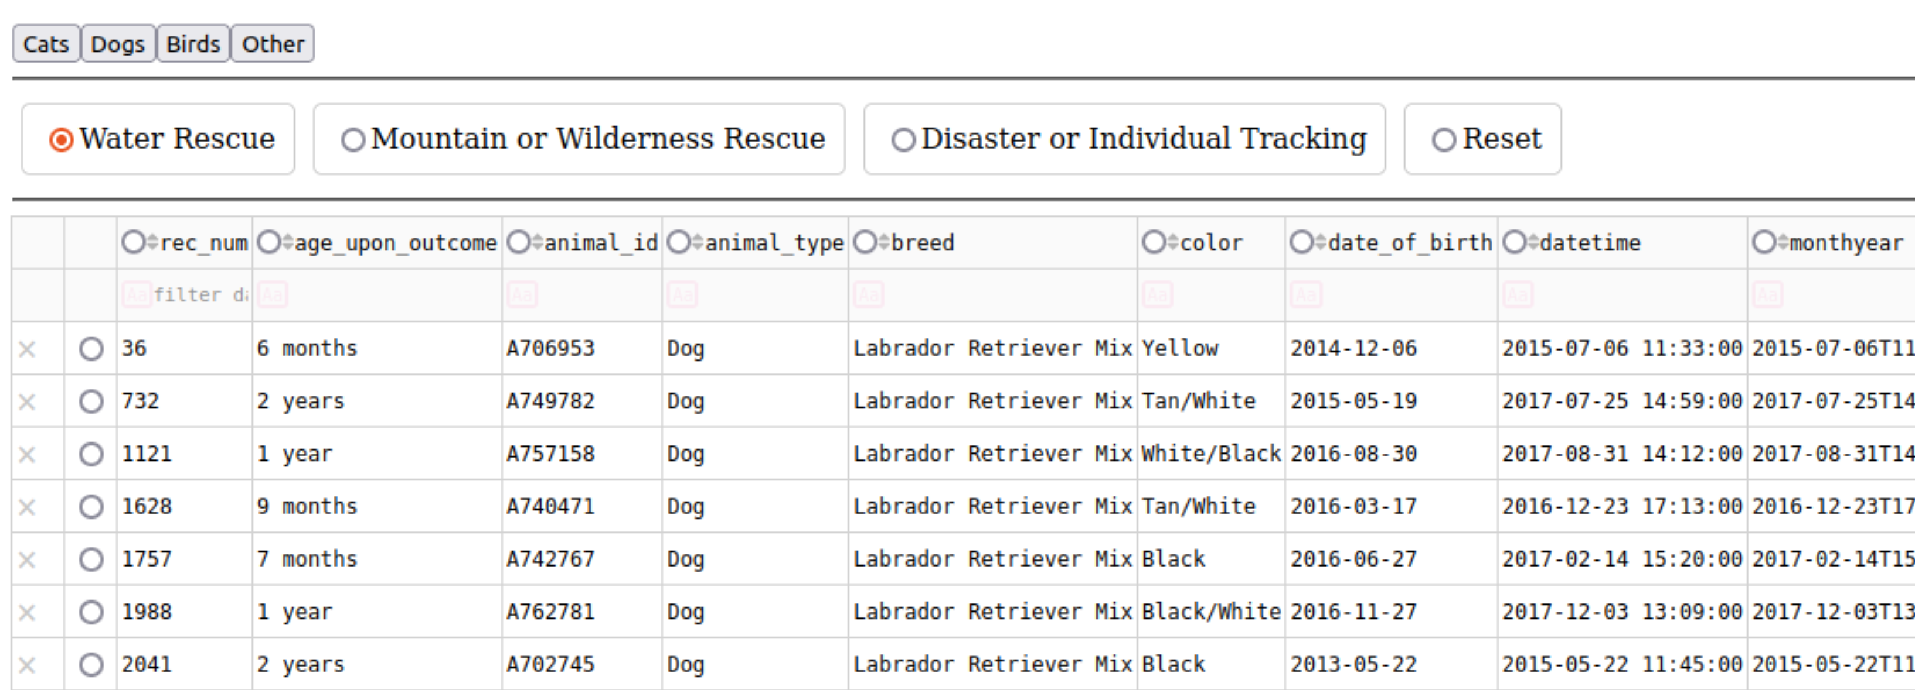

Results of the chart after pressing “reset” (Note: reset only resets the rescue search bar and NOT the animal filter buttons)
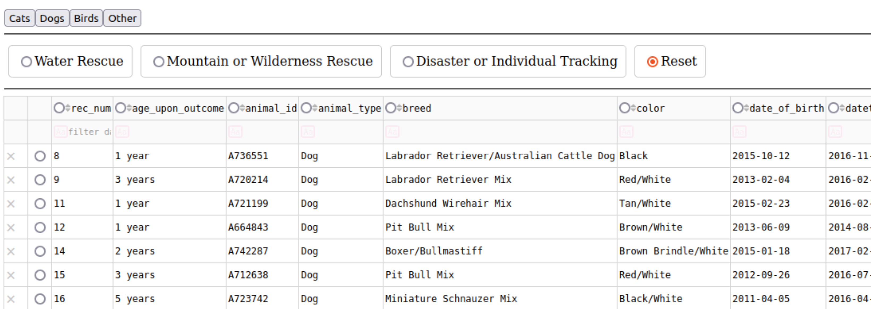

The information in the chart can be updated and deleted from the data table page. FInd whichever entry you wish to edit and select the cell you’d like to edit:
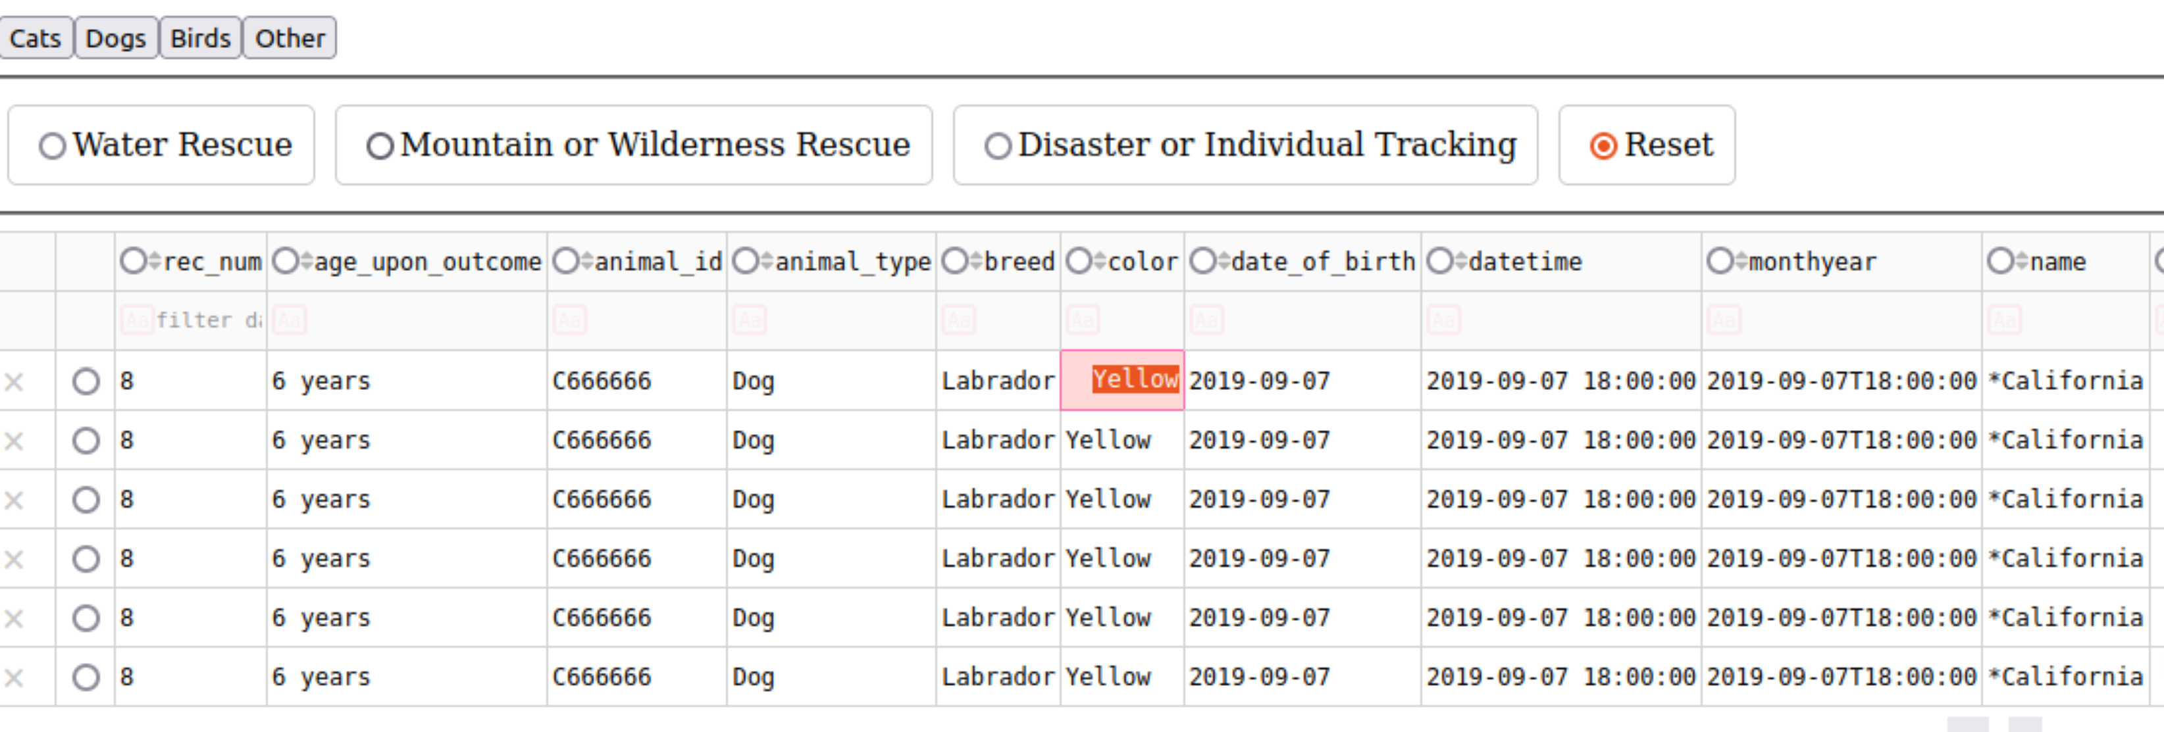

And then type in the new information you’d like to add and be sure to press the “enter” key.

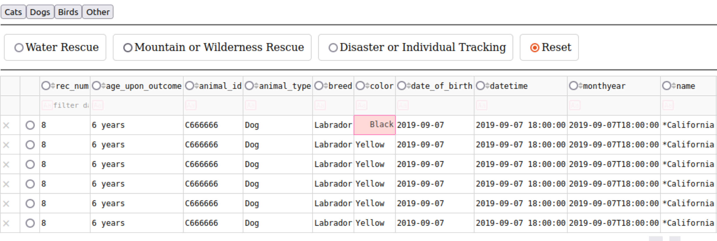

To delete a row, just press the X located on the left side of the screen adjacent to your row.
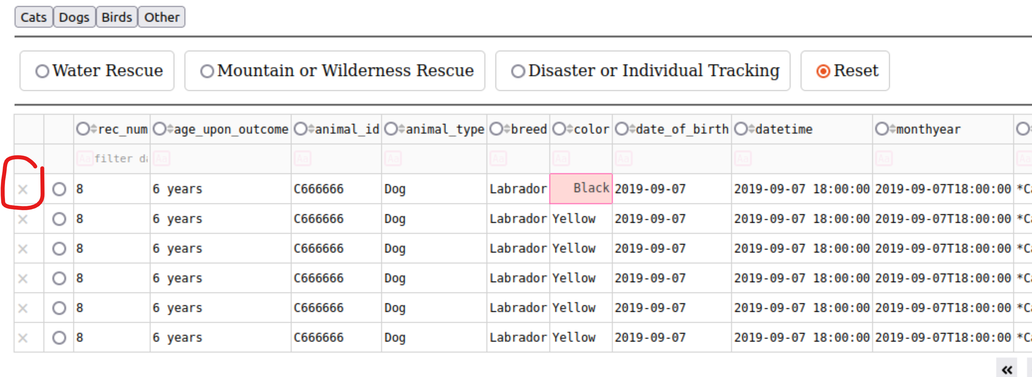

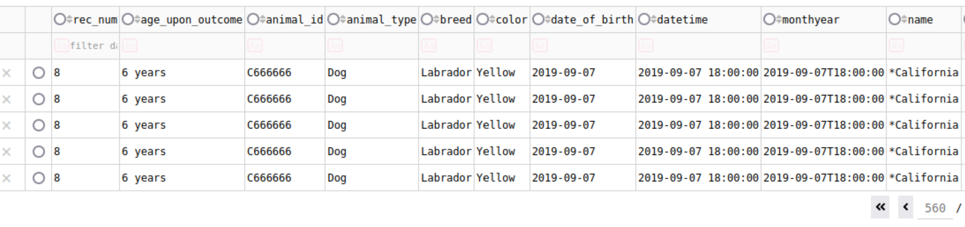

You can also use the uppermost row to filter data, just insert your search term and hit the “enter” key
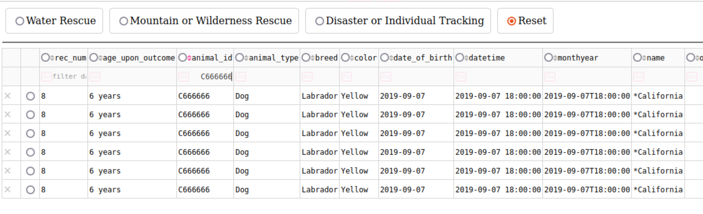

The charts beneath the data table update in real-time based on your filtering options. For example, if we filter by “Mountain or Wilderness Rescue” we’ll see the total amount of dogs by breed that can do that Job.

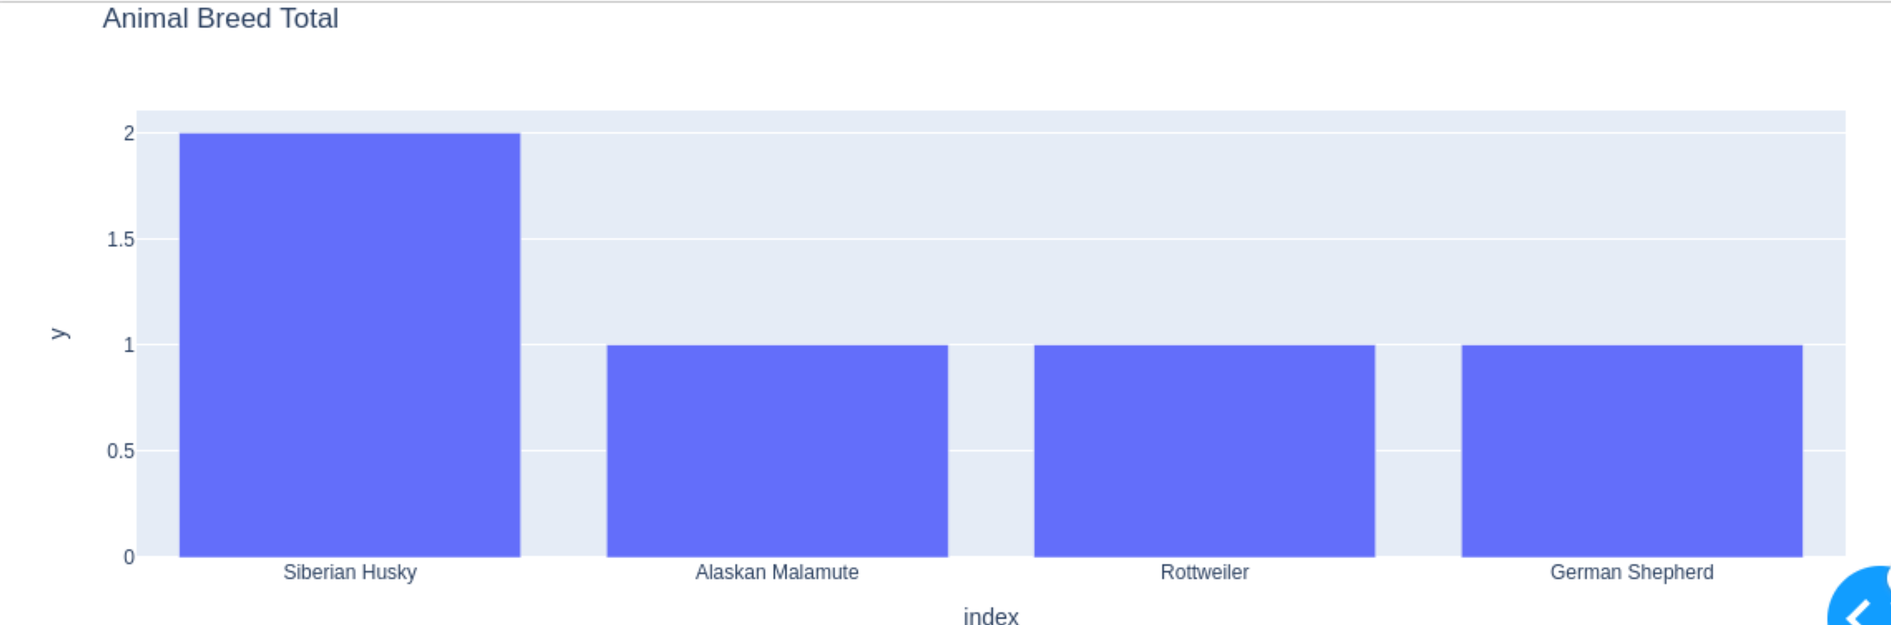

If you select a specific dog from the list, the geolocation chart will update to show you where that dog is:
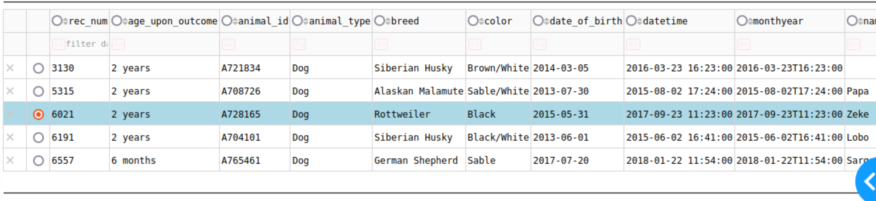

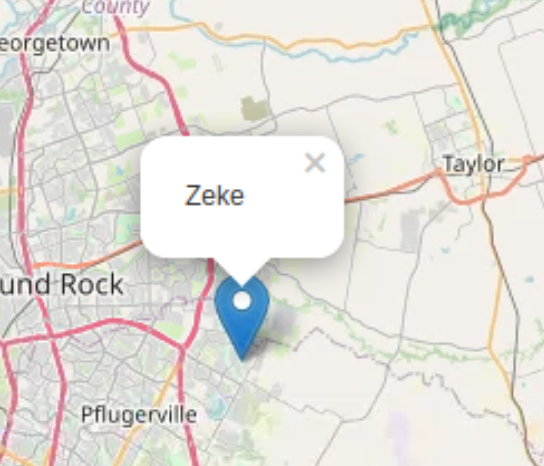

- Identify any challenges that were encountered and explain how those challenges were overcome.
The Making of the Project

This project began by accessing the AAC database provided by the Austin Animal Shelter. With new access to the database, work continued with setting up an account that would be capable of reading and writing data in the database. After the account had been set up, code was written in snippets for CRUD functionality, allowing for the Creation, Reading, Updating, and Deleting of the data within the database. When CRUD functionality had been written, tests were made to ensure that the code was operable. Afterward, a test was set up to deploy the database in the dash framework, before finishing the project with an interactive table and dynamic charts.

Challenges with the project

One large challenge began when testing the functionality of the CRUD module, after much trial and error, it became apparent that the AAC database was not being properly accessed by the CRUD module, and a new aacuser account had to be created which fixed a lot of the issues and allowed for proper testing to begin.

Another issue that came up was time. Much of the project went smoothly, but when it came time to deploy the dashboard and its dynamic charts, the project was not completed in the proposed timeline and had to be pushed back a week. This was mostly due to outside responsibilities that got in the way of the project and was partly due to the developer being new to the Dash framework and its functionality.

